**Gartner Magical Quadrant Analysis**

Gartner Magical Quadrant (MQ) is market research report and visualization by IT consulting firm Garner. This tool is for monitoring and evaluating the progress and position of companies in technology-based market. This would help the company understanding market trends and compare their position with the other competitors. By showing ranking companies in quadrants, which are based on two factors, completeness of vision and ability to execute it. The Gartner Magical Quadrant separates in four categories

Niche Players: Scoring low in both completeness of vision and ability to execute, these companies may narrowly focus on specific market but cannot outperform larger vendors. Usually focused on specific region or are local business.

Visionaries: Have aware ness of how the market will evolve and understand market trend but not be able to execute their visions. Normally in the start-up business try to escape from the mature markets.

Challengers: Be able to execute or well enough to be a threat to vendors in Leaders quadrant. They may have strong product in mature markets and well known in the market but lack of strong vision or they don’t want to change their current plan however if their got their vision, they would have potential to become leaders.

Leaders: The vendors in the Leader quadrant have the high scores in both of completeness of vision and ability to execute. A vendor in the leader quadrant has market share, understand the market trend and capability to create an invention which could affect the market’s overall direction.

**Scope of this analysis**

In this analysis, we focus on two major suppliers’ supermarkets only in New Zealand which are Foodstuffs and Woolworths (New Zealand). In this topic we want to analysis is Analytics and Business Intelligence Platforms base on Gartner Information. Two large companies are using a different platform to analysis their business. Woolworths is using IBM to operate its system (1) and Foodstuffs is running the operating system on SAP. AS you can see in this figure 1 SAP operation is in the Visionaries quadrant, but IBM is in Niche player, one of the reasons is, SAP operation system is allowed to accumulate and transform large amounts of data to have an integral and more complete vision of the Company. It also allowed revealing hidden trends and finding answers in order to help make decisions based on objective data and transmit their results. An efficient tool that allows the fast manipulation of data with attractive visualizations that make it possible to combine and analyze data from different sources. (2) If compare with IBM It lacks though better-integrated visualization tools and native integration with other IBM products. (3). According to Figure 1. This would help Foodstuffs understanding their business position and future Market trend to analysis their data which may drive their business into the Leader position for example by using Tableau to improve their data visualization and even new users can use it. (4)

Gartner Magical Quadrant for Analytics and Business Intelligence Platforms base on Gartner Data

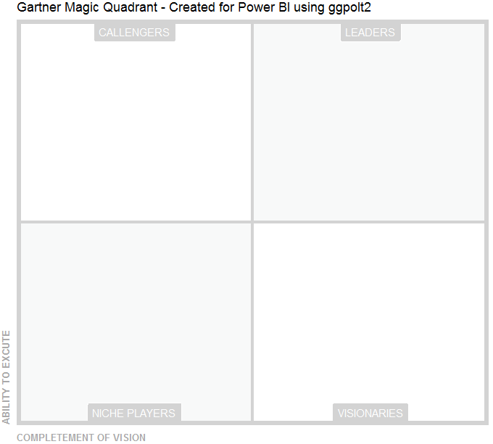

Foodstuffs (SAP)

Woolworths (IBM)

Introduction

<https://en.wikipedia.org/wiki/Magic_Quadrant>

<https://whatis.techtarget.com/definition/Gartner-Magic-Quadrants>

Analysis

(2)<https://www.gartner.com/reviews/market/data-science-machine-learning-platforms/compare/ibm-vs-sap>

(3)<https://www.gartner.com/reviews/market/analytics-business-intelligence-platforms/compare/sap-vs-ibm>

(4) <https://www.gartner.com/reviews/review/view/571639>

Woolworths

(1) <https://en.wikipedia.org/wiki/Woolworths_Group_(Australia)>